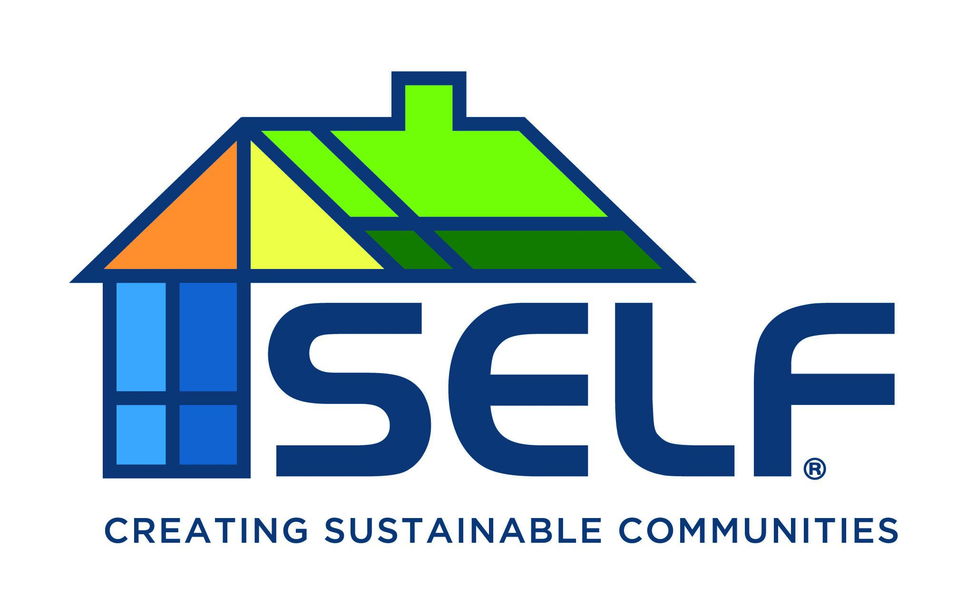
Join our established, fast-growing organization and learn from the Nation’s first local green bank. You'll have the chance to lead, build, and shape the organization’s future, while accelerating your personal and professional growth.

Organization: Solar and Energy Loan Fund (SELF)
Job Title: Policy Associate
Location: Remote
About SELF:
SELF is a national award-winning non-profit Community Development Financial Institution (CDFI) with a mission to rebuild and empower underserved communities by providing access to affordable and equitable capital to homeowners, landlords, developers, contractors, and small businesses to help transition communities towards an inclusive clean energy economy. Founded in Florida, SELF has expanded and now serves most of the Southern United States.
SELF is seeking a Policy Associate to support its work related to the Greenhouse Gas Reduction Fund.
Key Responsibilities:
Monitor and Analyze Policy Developments: Stay informed on federal, state, and local policy changes and trends related to green financing and the broader sustainability industry. Analyze impacts on the organization's strategy and operations.
Regulatory Compliance: Support SELF’s buildout of its compliance toolkit to ensure projects align with GGRF funding regulations, from initial project assessment to final reporting.
Grant and Funding Opportunity Analysis: Identify and analyze new grant and funding opportunities related to SELF’s mission. Assist in the preparation of grant applications.
Policy Education: Develop educational programs and workshops for internal staff and external partners on relevant policies, regulations, and best practices.
Collaboration on Project Development: Work closely with project teams to integrate policy considerations into project planning and execution, ensuring alignment with regulatory requirements.

Desired Skills and Experience:
- Understanding of environmental policies and green lending
- Excellent analytical and communication skills
- Proven ability to navigate complex regulatory environments and drive compliance
- Strong relationship-building and stakeholder management capabilities
- Proactive, innovative mindset with the ability to work independently and as part of a team

Apply:
If you are interested and ready to join a national leader that provides innovative financing and technical assistance to communities across the nation to achieve an inclusive and equitable clean energy economy that benefits all Americans, please submit a resume and cover letter to David Graber at davidg@solarenergyloanfund.org.

