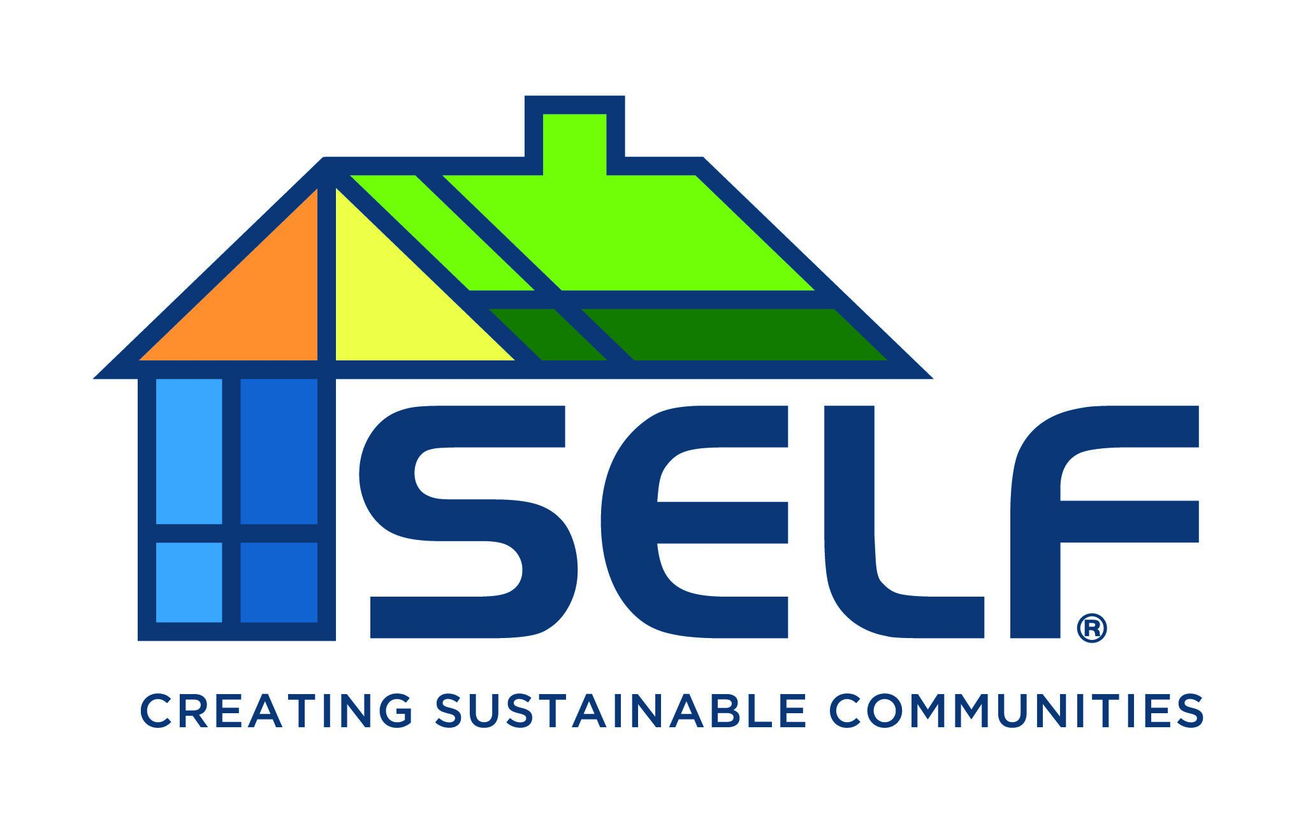
Join our established, fast-growing organization and learn from the Nation’s first local green bank. You'll have the chance to lead, build, and shape the organization’s future, while accelerating your personal and professional growth.

Organization: Solar and Energy Loan Fund (SELF)
Job Title: Housing and Community Development Director
Location: Hybrid-Remote. In-office two days a week.
Travel: 25%-30% of the time. Travel 1 week out of the month mostly in South Florida and Treasure Coast. SELF headquarters is in Ft. Pierce, Florida.
Classification: Exempt under FLSA
Salary Range: $99k-120k (commensurate with education and experience)
About SELF:
SELF is a national award-winning non-profit Community Development Financial Institution (CDFI) with a mission to rebuild and empower underserved communities by providing access to affordable and equitable capital to homeowners, landlords, developers, contractors, and small businesses to help transition communities towards an inclusive clean energy economy. Founded in Florida, SELF has expanded and now serves most of the Southern United States. Due in part to the recent passage of the Inflation Reduction Act, there is historically unprecedented momentum toward clean energy and home resilience. As the country’s first local Green Bank and an established and proven pioneer of climate equity, there is a need for SELF to lead this national movement. Thus, SELF is rapidly growing and hiring—a position with SELF provides enormous career growth opportunities while doing work that matters.
Position Overview:
The Housing and Community Development Director directs and oversees SELF’s SAGE Homes Loan Program which provides below-market-rate, flexible loans for small to mid-size affordable and workforce housing developments. Loans can be used for green pre-development, gap funding, equity-type investment options, and credit enhancement options. Capital is coupled with technical assistance and training to the minority black, Latino, and female-led small to midsize developers. This position supports SAGE’s lending goals of providing affordable housing, wealth building, and climate resilience.
The Housing and Community Development Director will focus on business development - seeking partners to work with on “greening” up projects; and seeking out and managing projects that align with SELF’s mission to finance small and midsize developments for novice minority developers. The individual will be leading one of SELF’s newest and most promising programs with enormous growth opportunities.
The individual should be passionate about climate justice and understand the intersections of climate and housing to ensure SELF projects are contributing to increasing access to resilient housing supply; decarbonization of the environment and resilient communities.
The Housing and Community Development Director will lead the development of SELF’s HCI (Housing and Community Impact Fund) and SAGE for multiple regions and grow SELF’s Green Housing portfolio and team.
Education, Experience, and Skills:
- Bachelor’s degree required, a focus in finance or real estate is preferred.
- Extensive experience in affordable housing and multi-family deal sourcing, deal analysis, deal underwriting, and other job-related activities with proven results is required.
- Experience with government housing programs, including the Low-Income Housing Tax Credit Program is required.
- Analytical, detail-oriented, and extremely organized.
- Strong research, writing, and presentation skills.
- Ability and willingness to travel to job sites, meetings with potential partners and clients, conventions, etc.
- Highly skilled in Excel and spreadsheet creation and analysis.

Essential Duties and Responsibilities:
- Direct and oversee the overall operations of the SAGE Homes Loan Program including prospecting, underwriting, funding, and identifying potential development opportunities and prioritizing them with the goals and mission of SELF and identified needs of the target market.
- Identify, analyze, conduct due diligence, and prepare and present internal memos on financial feasibility of potential development opportunities.
- Create and update project budgets, including monthly updates of project cost through completion.
- Research, create, and implement new financing strategies.
- Assist novice developers in structuring development deals.
- Research, analyze, and interpret local, state, and federal government affordable housing program rules, regulatory requirements, and qualified allocation plans, and gather necessary compliance documentation.
- Maintain an up to date working knowledge of the Low-Income Housing Tax Credit Program and other local, state, and federal funding sources.
- Prepare and submit loan and grant applications to government finance agencies and other funding sources.
- Collect and maintain data and documents to use to prepare reports for investors and funding sources.
- Establish and maintain strategic relationships with various lenders, developers, property owners, affordable housing associations, government officials, third party professionals (i.e., architects, engineers), and other key stakeholders to promote SELF’s SAGE Homes Loan Program.
- Represent the organization at community and business functions/groups to provide a positive image for SELF and the SAGE Program.
- Ability and interest in working with clients and colleagues from diverse backgrounds and cultures.
- Present to SELF during internal meetings, providing updates and reports.
- Other related duties as assigned.
Physical Demands and Vision and Hearing Requirements:
Candidate must have the ability to walk, stand, and sit for long periods, and must be able to lift and carry supplies weighing up to 20 pounds. The ability to communicate with internal and external clients via phone, email, video calls, and text is a daily expectation.
Top Benefits and Perks:
We provide comprehensive medical, dental, and vision benefits; a 403(b)-retirement plan with up to 5% match; performance-based bonuses; 12 paid holidays; a minimum of 21 days of paid leave; and paid leave to volunteer—something SELF is passionate about.
Apply:
If you are interested and ready to join a national leader that provides innovative financing and technical assistance to communities across the nation to achieve an inclusive and equitable clean energy economy that benefits ALL Americans, please submit a resume on our website at https://solarenergyloanfund.org/careers/. Inquiries welcomed.
SELF is an Equal Opportunity Employer:

SELF has established and adopted an Equal Employment Opportunity policy (EEO), and the purpose of this EEO policy is to ensure that all employment decisions are made on a non-discriminatory basis, and not based on race, color, religion (creed), gender, gender expression, age, national origin (ancestry), disability, marital status, sexual orientation, citizenship, pregnancy or maternity, or military status, in any of its activities or operations. These activities include, but are not limited to, hiring and firing of staff, selection of volunteers and vendors, and provision of services. We are committed to providing an inclusive and welcoming environment for all members of our staff, clients, volunteers, subcontractors, vendors, and clients.

SELF is an equal-opportunity employer. We will not discriminate and will take affirmative action measures to ensure against discrimination in employment, recruitment, advertisements for employment, compensation, termination, upgrading, promotions, and other conditions of employment against any employee or job applicant on the basis of race, color, gender, national origin, age, religion, creed, disability, veteran's status, citizenship, pregnancy or maternity, sexual orientation, gender identity or gender expression.

