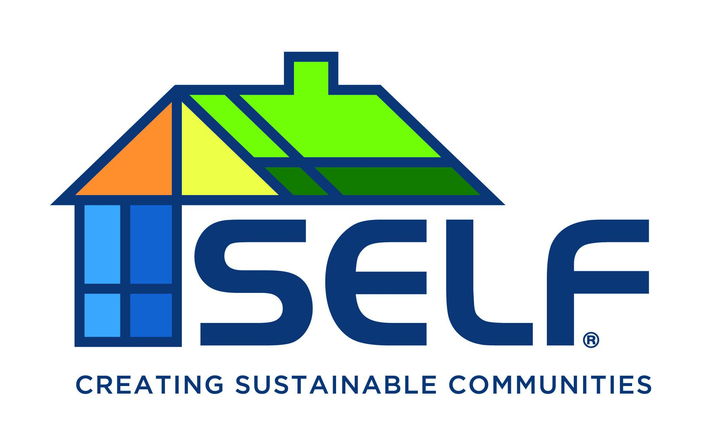
Join our established, fast-growing organization and learn from the Nation’s first local green bank. You'll have the chance to lead, build, and shape the organization’s future, while accelerating your personal and professional growth.

Organization: Solar and Energy Loan Fund (SELF)
Job Title: Solar Development and Engineering Associate
Location: Hybrid Remote: this full-time employee must be Florida based, with the ability and willingness to travel throughout Florida as required.
Classification: Exempt under FLSA
Salary Range: Will be commensurate with education and experience.
About SELF:
SELF is a national award-winning non-profit Community Development Financial Institution (CDFI) with a mission to rebuild and empower underserved communities by providing access to affordable and equitable capital to homeowners, landlords, developers, contractors, and small businesses to help transition communities towards an inclusive clean energy economy. Founded in Florida, SELF has expanded and now serves most of the Southern United States. Due in part to the recent passage of the Inflation Reduction Act, there is historically unprecedented momentum toward clean energy and home resilience. As the country’s first local Green Bank, and an established and proven pioneer of climate equity, there is need for SELF to lead this national movement. Thus, SELF is rapidly growing and hiring—a position with SELF provides enormous career growth opportunities while doing work that matters.
Position Overview:
SELF is looking for a highly motivated individual looking to make an impact in solar and climate equity. The Solar Development and Engineering Associate will be responsible for developing strategic plans, analyzing viability, conducting financial analysis, and designing solar products for SELF’s residential solar offerings. This position will also provide solar support and education to SELF staff. The Associate will be responsible for staying abreast of energy efficiency and renewable energy policy developments, residential solar trends, market research, tax incentives and rebates, etc. This is a mid-level position with vast room for growth.
Education, Experience, and Skills:
- Bachelor’s degree in finance, engineering, renewable energy technology, or a similar field.
- Expertise with solar and clean energy products, systems, finances, and industry trends.
- Familiar with project management, business transactions, proposals, and proformas.
- Proficient with all MS Office programs, particularly Excel; Salesforce experience is a plus.
- Excellent project and people management skills with a highly organized approach.
- Strong internal and external communication skills and an ability to manage multiple issues and clearly articulate outcomes, concerns, and solutions.
- Ability to analyze data and present findings orally and in report form.
- Desire to take on a key role in making an impact in solar and climate equity.

Essential Duties and Responsibilities:
Project Development:
- Conduct technical due diligence of energy efficiency and clean energy projects under consideration for SELF financing.
- Conduct project analysis and present reports and/or presentations on the financial viability of residential solar and clean energy projects.
- Create and review solar and clean energy proposals and proformas.
- Develop and maintain a solar product database.
- Stay abreast of relevant energy efficiency and renewable energy policy developments.
- Conduct new market research and development opportunities, including emerging solar markets, energy storage, and low-income community solar.
- Coordinate and track solar and clean energy projects under development through closing.
- Validate the reliability of energy and cost savings projections and make recommendations to SELF.
- Opine on project cost estimates and highlight risks associated with projected cost and project implementation.
- Establish and maintain energy performance recording and reporting mechanisms.
Loan Officer Support:
- Support loan officers by providing information on the advantages of solar energy, including cost savings, environmental benefits, and available incentives or rebates.
- Work with loan officers to assist them in achieving individual and team sales targets, sharing insights and best practices to enhance overall sales effectiveness.
- Support loan officers with all aspects of solar project operation.
- Special projects as needed, some to include collaborating with SELF partners.
Client and Contractor Relations:
- Build and maintain strong relationships with contractors.
- Provide exceptional customer service to clients throughout the installation process and address any post-sale inquiries or concerns.
- Conduct site visits to manage homeowner engagement, solar development diligence, and local permitting and tax abatement processes.
Physical Demands and Vision and Hearing Requirements:
Candidate must have the ability to walk, stand, and sit for long periods of time, and must be able to lift and carry supplies weighing up to 20 pounds. The ability to communicate with internal and external clients via phone, email, video calls, and text is a daily expectation.
Top Benefits and Perks:
We provide a comprehensive medical, dental, and vision benefits; and a 403(b)-retirement plan with up to 5% match; performance-based bonuses; 12 paid holidays; a minimum of 21 days of paid leave; and paid leave to volunteer—something SELF is passionate about.
Apply:
If you are interested and ready to join a national leader that provides innovative financing and technical assistance to communities across the nation to achieve an inclusive and equitable clean energy economy that benefits ALL Americans, please submit a resume on our website at https://solarenergyloanfund.org/careers/. Inquiries welcomed.
SELF is an Equal Opportunity Employer:

SELF has established and adopted an Equal Employment Opportunity policy (EEO), and the purpose of this EEO policy is to ensure that all employment decisions are made on a non-discriminatory basis, and not based on race, color, religion (creed), gender, gender expression, age, national origin (ancestry), disability, marital status, sexual orientation, citizenship, pregnancy or maternity, or military status, in any of its activities or operations. These activities include, but are not limited to, hiring and firing of staff, selection of volunteers and vendors, and provision of services. We are committed to providing an inclusive and welcoming environment for all members of our staff, clients, volunteers, subcontractors, vendors, and clients.

SELF is an equal opportunity employer. We will not discriminate and will take affirmative action measures to ensure against discrimination in employment, recruitment, advertisements for employment, compensation, termination, upgrading, promotions, and other conditions of employment against any employee or job applicant on the bases of race, color, gender, national origin, age, religion, creed, disability, veteran's status, citizenship, pregnancy or maternity, sexual orientation, gender identity or gender expression.

